**Serialization No. 3**

Ultrasonic Applied Technology - Ultrasonic Deburring, Ultrasonic Polishing

　　　The application of the giant cavities (micro vacuum nuclei), which can reach 10 mm in diameter, does not stop at simply powerful unmatched ultrasonic cleaning. As a deburring cleaning device after machining and precision molding, it is used in the manufacturing processes of automotive parts, electronic parts, medical parts, etc. **Ultrasonic deburring and cleaning equipment [Photo 1]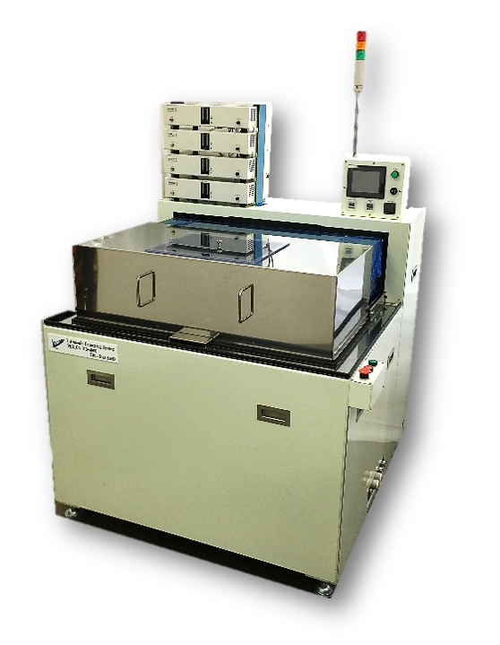 [Photo 1] Example of standard machine**

As can be seen from the principle, the target of ultrasonic deburring can be any material. Basically, it can be applied to almost any material, including metals, plastics, ceramics, and composites of these materials, although there are degrees of difficulty. In addition, it is not restricted by shape, the location of burr generation is multi-directional, and tolerance holes on the inner surface can also be targeted.

We are often asked how large a burr can be removed. The size of the burr is not so much relevant, but the thickness of the base of the burr is important. If the thickness at the base of the burr is approximately 0.1 mm, there is a high possibility that it can be removed. However, there are no practical examples of removal of burrs from soft materials such as rubber and silicone, where stress fracture is less effective, and the process is still in the research stage.

The deburring cleaning time varies from less than 30 seconds to about 30 minutes, with the irradiation time determined by the thickness of the root of the burr and the location of the burr.

The number of pieces processed can be from one to tens of thousands at a time or continuously. ［**Photo 2 (4)**

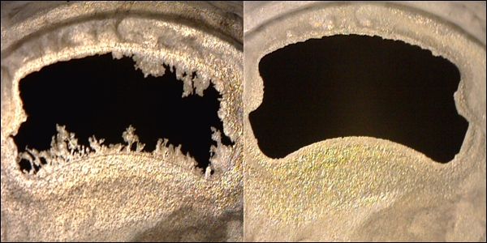PPS molding process burrs [Photo 2]

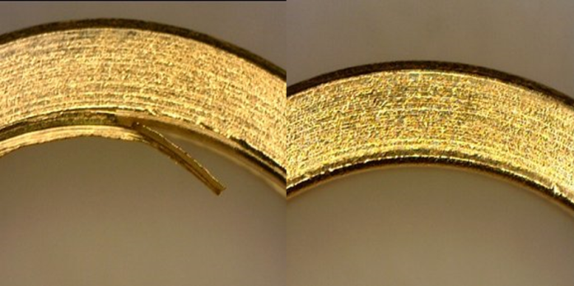 SUS burr [Photo 2]

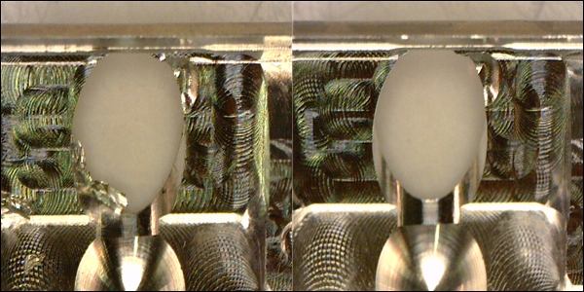Aluminum cutting burrs [Photo 2]

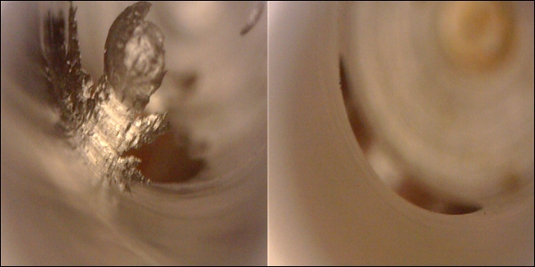Iron Cross-hole burr [Photo 2].

Even if the irradiation time is long, it is often only a few seconds per piece, considering the processing time per piece, since it is automatic and capable of deburring and cleaning a large quantity of pieces.

In addition, while ordinary deburring methods require cleaning after deburring, the ultrasonic deburring/cleaning system performs precision cleaning at the same time, thus eliminating the need for a cleaning process in the next process.

　This powerful ultrasonic wave is also causing innovation in the world of barrel polishing. This is **ultrasonic barrel polishing [Photo 3]**. Here, I would like to talk about ultrasonic applied technology and "ultrasonic polishing," barrel polishing without the use of media, which was thought to be impossible.

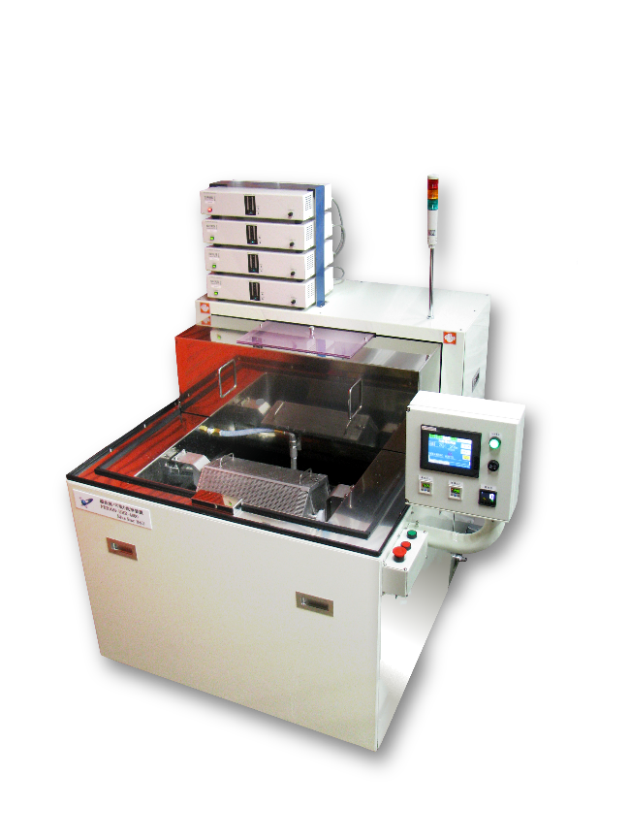Photo 3: Ultrasonic barrel finishing equipment

The rotating cage was initially intended to improve deburring efficiency, but it was confirmed that it could also perform polishing, and is now standardized as an ultrasonic barrel finishing machine that can perform barrel finishing using only ultrasonic waves and water, and continues to be delivered.

We believe that bearing retainers, precision pressed parts for watches, and other workpieces that currently use conventional barrel finishing can be replaced by media-less ultrasonic barrel finishing without problems.

In the case of ordinary barrel finishing, polishing is performed by physically rubbing the media and workpiece together, but the media and workpiece are rotating at approximately the same speed. How many times per second do the media and workpiece rub against each other?

In the case of ultrasonic barrel polishing, the cavities are impacted 25,000 times per second. Furthermore, the slow rotation of the hexagonal cage causes co-friction between products, which is more than twice as fast as general barrel polishing, and the same level of polishing ability has been confirmed.

This is ultrasonic barrel polishing, which has realized media-less, which was thought to be impossible.

What does it mean not to use media?

First, media and workpiece separation is no longer necessary, eliminating defects caused by media clogging. Media replacement and management will no longer be necessary, and the heavy labor required due to media will be replaced by light labor. Furthermore, the deburring and polishing speed is several times faster than that of existing barrels (customer evaluation). Furthermore, since precision cleaning is performed at the same time, it can be used for electronic parts with complex shapes that do not tolerate contamination. Since the liquid is not contaminated, wastewater treatment is not required. In addition to city water, pure water, water-soluble rust inhibitors, and hydrocarbon solvents can be used. Drying is also easy and can be fully automated.

Simply eliminating media will reduce labor costs, stabilize quality, reduce expenses, and increase production efficiency.

［Photo 4] shows an ultrasonic deburring, polishing, cleaning, and drying system for precise, complex shapes. Automation is easy, and there are reported cases of ultrasonic deburring, polishing, cleaning, and drying of 3,000 to 25,000 workpieces at a time.

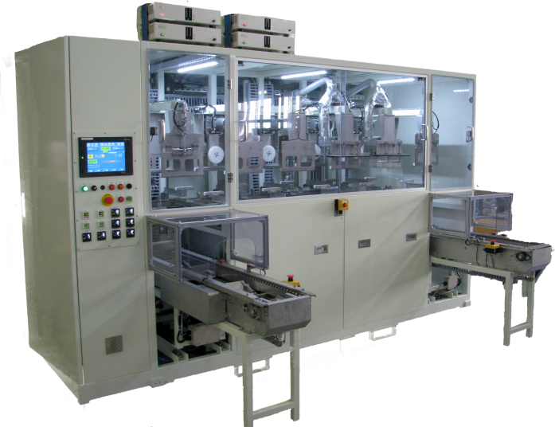［Photo 4] Ultrasonic deburring, polishing, cleaning and drying equipment

**Serialization No. 4**

Ultrasonic Deburring Technology and Its Development

Here is a brief review of the history of ultrasound.

It was around 1993 that cavities (microvacuum nuclei) generated by ultrasound evolved from "gas nebula type" cavities, which are a collection of microcavities with a maximum diameter of about 0.5 mm and smaller, to "globular nebula type" cavities with a diameter of 3 to 4 mm, and began to be used.

We consider these days to be the beginning of the era of full-scale ultrasonic precision cleaning technology.

In 2012, an ultrasonic vibration element dedicated to deburring was developed to stably generate cavities with a diameter of 6 to 7 mm, and an ultrasonic deburring and cleaning device was put into practical use.

In 2017, an even newer ultrasonic deburring vibrating element was developed, successfully generating giant cavities of 10 mm in diameter. Stable utilization is now possible.

　The third generation ultrasonic cleaning technology - Cavitation Enhancement System is opening up a completely new field as a new applied technology and ultrasonic deburring cleaning.

Let me explain the principle of ultrasound once again.

When using 25 kHz ultrasound, the cavity [a group of microvacuum nuclei] reaches its maximum shape in approximately 5,000ths of a second after the onset and disappears in the next 5,000ths of a second. This is repeated 25,000 times per second. In the case of a spherical nebula cavity with a diameter of 10 mm, this means that a liquid volume of 10 mm in diameter moves at high speed away from the center of the cavity in 1/5000th of a second. The impact force generated at this time is called a positive shock wave. In the next 5,000th of a second, the cavity disappears. This means that the liquid outside the vacuum core with a diameter of 10 mm reaches the center of the cavity in 1/5000th of a second. The shock wave generated at this time is called a negative shock wave.

When measured accurately, the speed of cavity generation and annihilation are not the same; annihilation is about 20% faster. In other words, the negative shock wave is larger.

Therefore, since the total impact energy of the cavity is due to the high-speed movement of the liquid, its kinetic energy is proportional to its mass and to the square of its velocity, which in this case can be said to be proportional to the third power of its diameter and to the square of its diameter if the travel time is the same. Of course, it is not that simple, since a single cavity is a collection of smaller vacuum nuclei, but it is clear that the size of the cavity has a significant effect on the magnitude of the positive and negative impact forces.

Ultrasonic deburring and cleaning technology removes burrs from their roots by stress fracture through the repetition of positive and negative shock waves - pushing and pulling - 25,000 times per second by spherical nebula-shaped cavities attached to the burrs.

See Figure 1.

　This figure is a simple illustration of an image taken by a high-speed camera in 1993. The frequency of the ultrasound at this time was 25 kHz.

(1) Cavity generation : Microcavity nuclei begin to appear, distributed on average in a space of approximately 6 to 10 mm in diameter.

(2) Microcavity growth : Microcavities grow individually and the liquid pushed away moves at high speed around the cavities. Shock waves (positive shock waves) are generated in the direction away from the central core.

(iii) Growth limit of microcavities ： Microcavities grow to a size where they collide with each other. Cavities are spherical in shape and 6 to 10 mm in diameter.

(4) Cavity shrinkage: The microcavity shrinks and the liquid around the cavity moves toward the center. At this time, the burrs are subjected to a pulling force in the opposite direction. (Negative shock wave)

5)

(5) Extinction of microcavity ：Microcavity disappears.

(6), (7) Mechanism of deburring: Positive and negative shock waves are generated as cavities grow and disappear. Pushing and pulling forces are alternately generated on the burr, and this is repeated 25,000 times per second. Comparing the time from generation to the growth limit and the time from the growth limit to extinction, the time to extinction is clearly faster. This is due to the effect of water pressure plus atmospheric pressure. Hence, a more powerful force is exerted around the cavity by a negative shock wave than by a positive shock wave. One of the main features of ultrasonic deburring is that it causes burrs that are stuck to the surface to be removed from their roots.

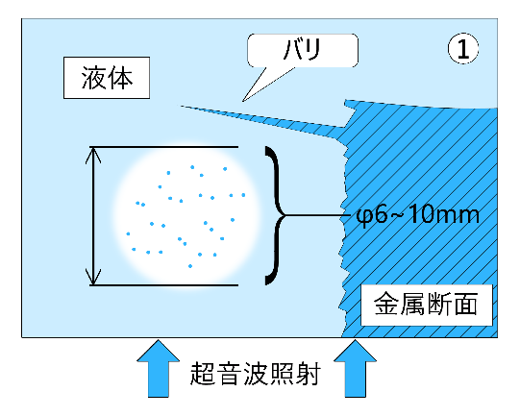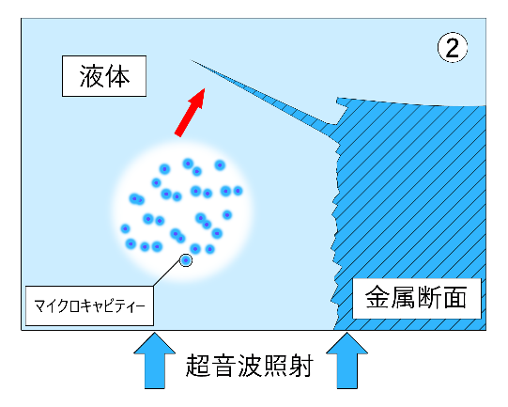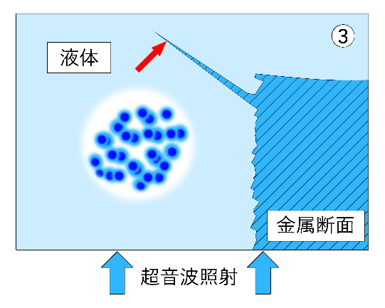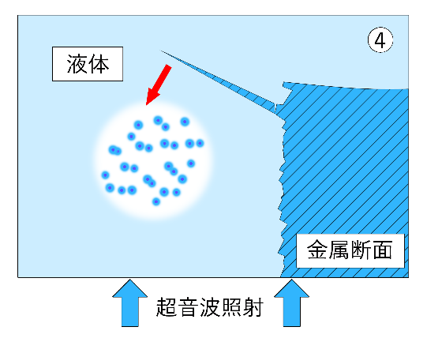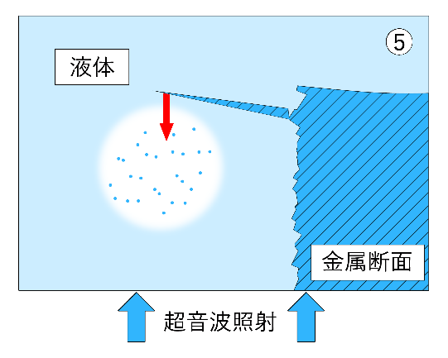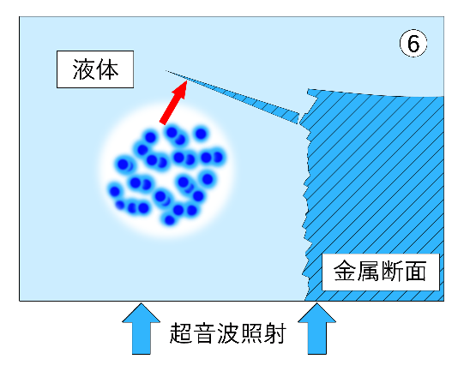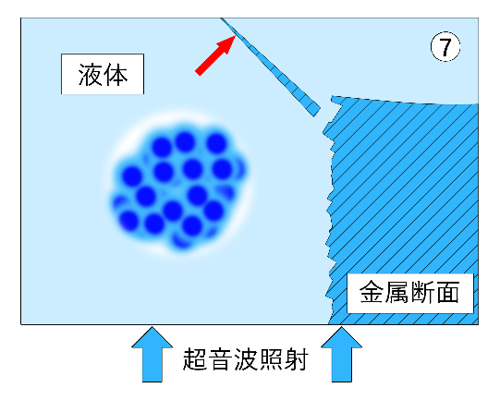

Water is the most commonly used liquid, but rust-preventive oils, coolant fluids, hydrocarbon solvents, and other solvents can be used depending on the purpose.

The ultrasonic deburring systems are supplied to a very wide range of customers, including automotive parts, semiconductor parts, smart phones and other communication device parts, aircraft parts, medical parts, semiconductor parts, and textile-related parts.

Features of ultrasonic deburring cleaning

　Ultrasonic deburring has many unique features. It is a new means of processing that reduces labor costs, stabilizes quality, and lowers costs by automating the process.

1. No choice of material

Basically, it can handle almost all materials, including metals, plastics, ceramics, and their composites, although there are some degree of difficulty.

2. Unrestricted by shape

Burrs occur in multiple directions, including tolerance holes on the inner surface.

3. Not limited in number

From one to tens of thousands of pieces can be processed at a time or in succession.

4. No hazardous materials are generated

Hazardous materials are not used and, in principle, water is used. Environmentally friendly.

5. Burrs can be removed while cleaning without contaminating the material to be cleaned.

At the same time, precision cleaning is possible.

6. No special technology or skills are required for use.

Easy to automate and therefore easy to manage.

7. Micro burrs (micron size) can be removed more quickly and reliably.

It is the only deburring method that can be used for future ultra-precision machining.

8. Low consumables

Unlike other means, daily maintenance is not required, and the only consumable is the filter, so running costs are low.

9. Low equipment costs

The system is far less expensive than other competing methods that require precision ultrasonic cleaning after deburring.

10. Drying can also be made into a line.

Suitable for treatment of air from precision parts processing due to low re-deposition of stains.

11. No need for isolated deburring, cleaning rooms, etc.

The above advantages mean that they can be installed in a clean room or other environment, and do not require isolated deburring and cleaning rooms, as other means do, reducing administrative costs.

The Future of Ultrasonic Deburring Technology

The movement to view cavities generated by ultrasonic waves as a new machining tool seems to be quietly spreading. Cavitation application technology, when utilized for deburring, requires the stable generation of more powerful and larger cavities. To do so, it is necessary to maintain a stable cavitation distribution in the chamber used, and various measures must be taken to prevent the ultrasonic chamber from breaking down. To ensure stable cavity generation over a long period of time, a large ultrasonic vibration element dedicated to deburring has been successfully developed, and a circuit has been developed to enable 50 to 200 vibration elements to oscillate stably and synchronously.

Practical output power ranges from 600W to 21,000W.

Ultrasonic diaphragm management technology and maintenance and repair techniques are also undergoing significant change.

We are confident that ultrasonic deburring technology will continue to evolve steadily, accompanied by the development of peripheral control technologies.

　　　　　　　　　　　　　　　　　　　　　　　　　　　　　　　　　　　　　　　　　　　　　　　　　　　　　　　　the end